1. <https://www.youtube.com/watch?v=gCHUGgcGV48&list=PL3cFiqLUjlYPGlWWszesTtdI3v0tcLe5E&index=2>
2. Text

   Description automatically generated
3. Let’s start with understanding about Market?
4. If we want to purchase something like Veg, Furniture, we go to market. Similarly, we go to **Stock Market** to purchase **shares** of a company.  
   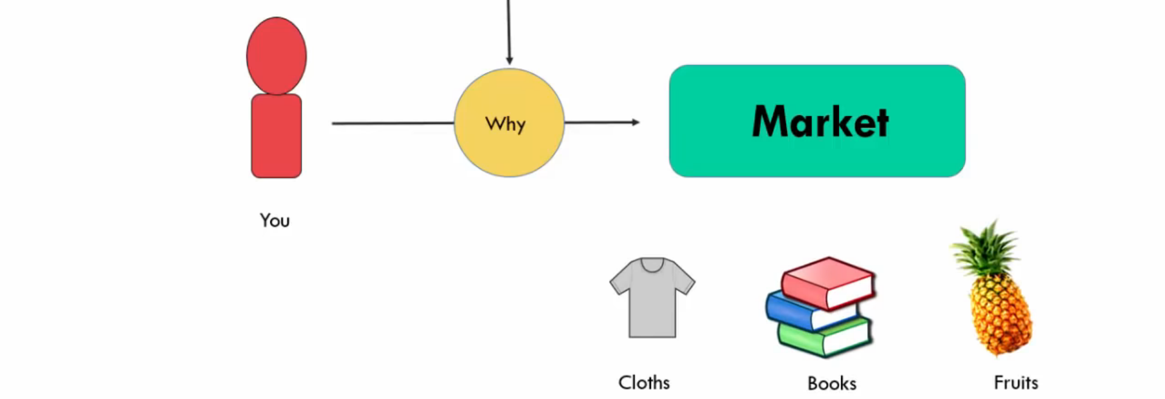  
   Diagram

   Description automatically generated  
   We don’t need to go to market to purchase shares but can do online.
5. **Shares VS. Stocks**:  
   Diagram

   Description automatically generated
6. Diagram

   Description automatically generated
7. A picture containing diagram

   Description automatically generated
8. 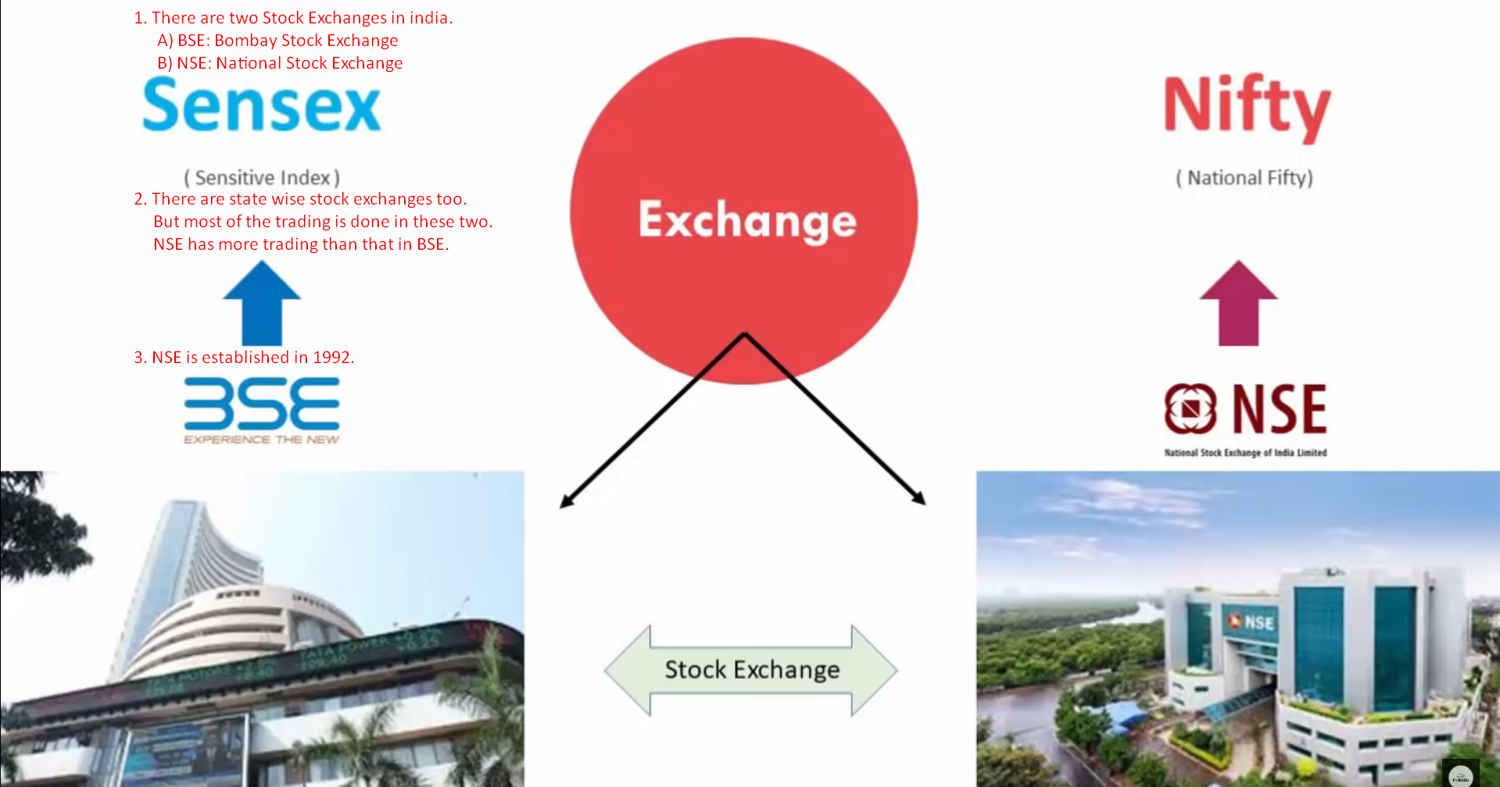
9. There are two ways to purchase shares of a company.
   1. Diagram

      Description automatically generated
10. Can we buy directly from Stock Exchange Website?  
    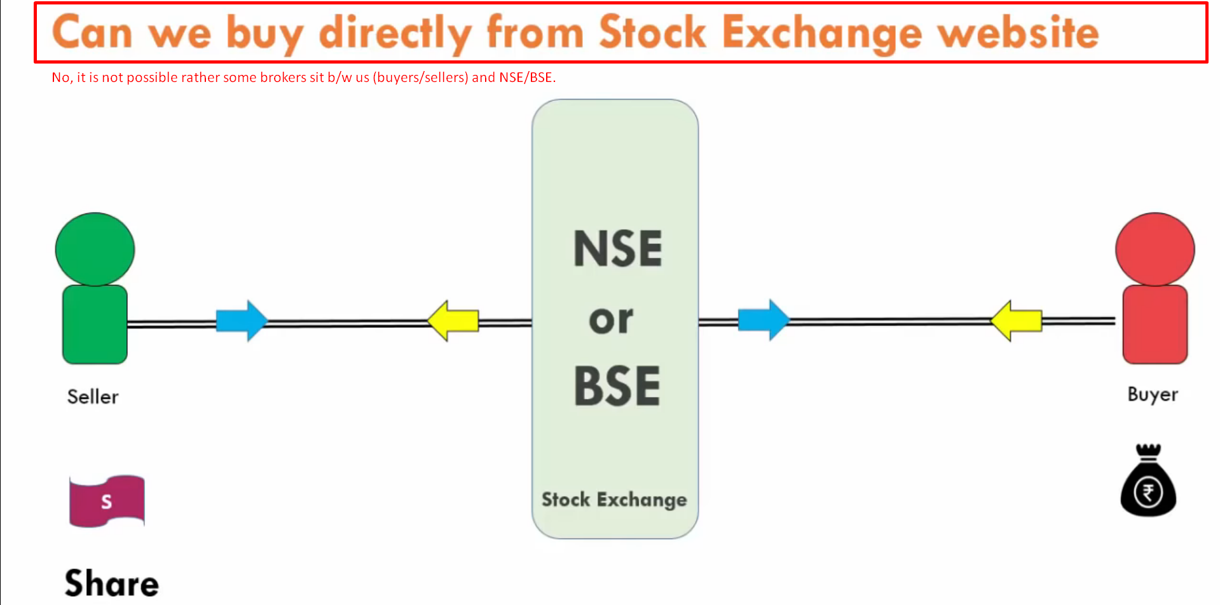  
    There are registered members to BSE/NSE and those are called 🡺 **Depository Participants** which are called **Brokers**.  
    So, to do any kind of trading (buying/selling shares) activities, you need to open account with a **Broker**.  
    It is very similar to Bank.   
    If you want to open with RBI, you can’t do it directly but go through public or private Banks and further transactions are settled through **RBI Route**.   
    Similarly, any trading will go to NSE/BSE through Broker (Depository Participant) and settlement will be done by NSE/BSE.
11. 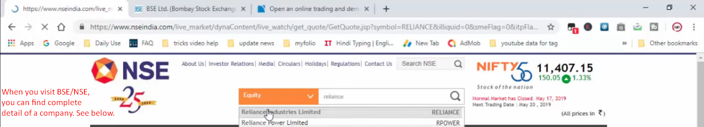
    1. Turnover.
    2. Market Capital.
    3. Share Price.
    4. float Size.
    5. Turn Over so far.
    6. Profit of a company.
    7. Who is promoter.
12. 